Computer Organization and Architecture
CPE 343
Lab Manual



Name
Registration Number
Class
Instructor’s Name

Introduction
This is the Lab Manual for CPE – 343 Computer Organization and Architecture. The labs constitute 25 % of the total marks for this course.
During the labs you will work in groups (no more than three students per group). You are required to complete the ‘pre-lab’ section of the lab before coming to the lab. You will be graded for this and the ‘in-lab’ tasks during the in-lab viva. You will complete the ‘post-lab’ section of each lab before coming to the next week’s lab.
You are not allowed to wander in the lab or consult other groups when performing experiments. Similarly, the lab reports must contain original efforts. ECE department CUI Islamabad has a zero tolerance anti-plagiarism policy. The grading policy is already discussed in the Course Description File.

Acknowledgement
The labs for CPE343 Computer Organization and Architecture course were conceived by the lab manual of EEE343 designed by Dr. Adeel Israr (late) and Mr. Khiyam Iftikhar. The first version for the CPE343 course was prepared by Dr. Dilshad Sabir, Dr. Syed Saud Naqvi and Dr. Irfan Ullah. Previously, typesetting and formatting of some of the labs adopted in this version were supervised by Dr. Omar Ahmad and was carried out by Mr. Abdul Rehman, Mr Suleman & Mr Baqir Hussain.

History of Revision
Date of Issue | Team | Comments
Jan. 2022 | Dr. Syed Saud Naqvi  Dr. Dilshad Sabir  Dr. Irfan Ullah | This is the first editable draft of CPE 343 Computer Organization and Architecture lab manual.

Table of Contents
Introduction 2
Acknowledgement 3
History of Revision 3
Lab # 01 Introduction to MIPS Assembly 7
Objectives 7
Pre-Lab 7
In Lab 14
Critical Analysis / Conclusion 15
Lab # 02 Strings and Conditional Execution 16
Objectives 16
Pre-Lab 16
In-Lab 22
Critical Analysis / Conclusion 24
Lab # 03 Integer Arithmetic 25
Objectives 25
Pre-Lab 25
In-Lab 31
Critical Analysis / Conclusion 33
Lab # 04 Flow Control 34
Objectives 34
Pre-Lab 34
In-Lab 39
Critical Analysis / Conclusion 41
Lab # 05 Introduction to Verilog HDL Combinational Circuits 1 42
Objectives 42
Pre-Lab 42
In-Lab 55
Critical Analysis / Conclusion 57
Lab # 06 Combinational and Sequential circuits 58
Objectives 58
This lab includes a refresher of combinational and sequential circuits. 58
Pre-Lab 58
In-Lab 67
Critical Analysis / Conclusion 69
Lab # 07 Implementation and Simulation of the Instruction Fetch Module of MIPS 70
(Single Cycle Datapath) 70
Objectives 70
Pre-Lab 70
In-Lab 74
Post Lab 75
Critical Analysis / Conclusion 77
Lab # 08 Single Cycle MIPS Datapath (R-type and Load/Store) 78
Objective 78
Pre-Lab 78
In-Lab 82
Post Lab 85
Critical Analysis / Conclusion 86
Lab # 09 Single Cycle MIPS Datapath 87
(R-type and Load/Store) 87
Objective 87
Pre-Lab 87
In-Lab 87
Critical Analysis / Conclusion 89
Lab # 10 Single Cycle MIPS Datapath (R-type and Load/Store) 90
Objective 90
Pre-Lab 90
Today’s Tasks 90
In-Lab 95
Critical Analysis / Conclusion 96
Lab # 11 Single Cycle MIPS Datapath (Data Memory and Branch) 97
Objective 97
Pre-Lab 97
In-Lab 101
Critical Analysis / Conclusion 102

Lab # 01 Introduction to MIPS Assembly

Objectives
- Writing simple MIPS assembly programs
- Using Syscall

Pre-Lab

Introduction to MIPS Assembly

Assembly Language
Assembly language is closely related to machine language (sequence of bits). It is in human readable form. ‘Assembler’ is a program which converts the assembly language into the machine language. Every architecture has its unique assembly language.

MIPS Instruction Set
MIPS supports several instructions all of which may not be mentioned here. However, there are few instructions which form the basis for rest of the instructions. MIPS is a Load/Store architecture, so most of the instructions are register based.
R-Type Instructions  a. ADD $1, $2, $3  b. SUB $1, $2, $3c.  c. AND $1, $2, $3  d. OR $1, $2, $3  g. SLT $1, $2, $3  Memory Based Instructions  a. LW $1, offset($2)  b. SW $1, offset($3) | Jump Instructions  a. J Label  b. JZ Label  d. JR $1  ADD Immediate  ADDI $1, $2, offset  Pseudoinstruction  LI $1, Value ( Any 32bit integer value)  Move $1,$2  MUL $1, $t2, $t3

1.4Registers
The following table explains the 32 registers of MIPS for integer operations.
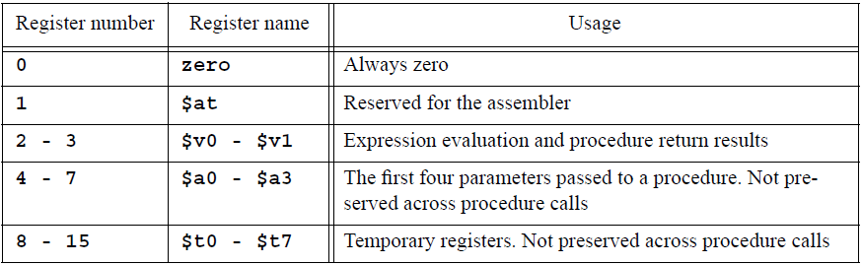
Table 1.1

MIPS Assembly Programming using MARS

MARS Simulator
MARS is a simulator for MIPS. It has been already installed on your systems. It requires java runtime environment (JRE) to be installed on your computer. Both MARS and JRE are freely available .
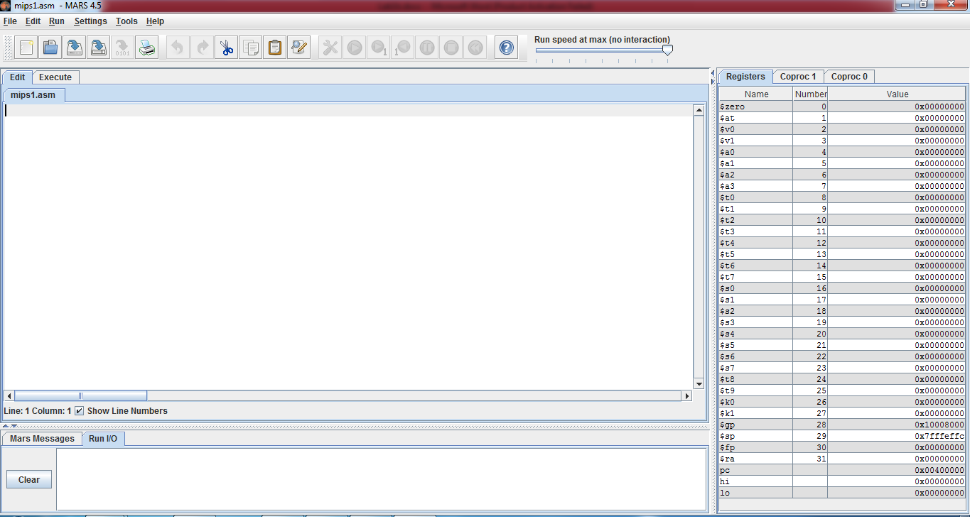
Figure 1.1
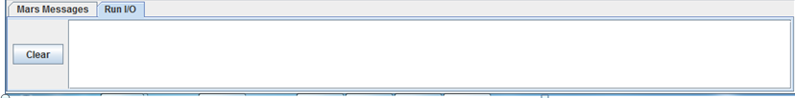
Figure 1.2(I/O Panel)
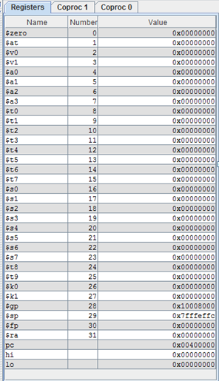
Figure 1.3 (Registers)
The side panel shows the contents of the register and the one at the bottom is for input/output.
To begin with MARS, let us write an assembly language program that computes the sum of 1 & 2 and stores the result in $t0. Having ‘comments’ in a code is always helpful for others in understanding what the code does. So, make sure you always put all the required comments in your code and use ‘#’ sign to begin your comments.
Open new file and write the folloeing code in it.
# Your Name Reg No Date
# add.asm-- A program that computes the sum of 1 and 2,
# leaving the result in register $t0.
# Registers used:
# t0 - used to hold the result.
# t1 - used to hold the constant 1.
li $t1, 1 # load 1 into $t1.
add $t0, $t1, 2 # $t0 = $t1 + 2.
# end of add.asm

Completing the Program
These two instructions perform the calculation that we want, but they do not form a complete program. Much like C, an assembly language program must contain some additional information that tells the assembler where the program begins and ends. The exact form of this information varies from assembler to assembler (note that there may be more than one assembler for a given architecture, and there are several for the MIPS architecture)

Labels
Labels are used to tag the address of a particular instruction. If it is required to jump back (for implementing loops) to a particular instruction, or jump forward (for implementing if -else); these are mentioned in the jump instructions

# Your Name Reg No Date
# add.asm-- A program that computes the sum of 1 and 2,
# leaving the result in register $t0.
# Registers used:
# t0 - used to hold the result.
# t1 - used to hold the constant 1.

main:
li $t1, 1 # load 1 into $t1.
add $t0, $t1, 2 # $t0 = $t1 + 2

Note that the MARS assembler does not permit the names of instructions to be used as labels. Therefore, a label named ‘add’ is not allowed, since there is an instruction of the same name.

Syscalls
Since you will practice MIPS assembly programming on a MIPS simulator which runs on different processor (Intel, most probably), running an operating system ( Windows); you can neither get input yourself from the user nor display result on screen.
Syscall is used to get the job done in this matter. Before calling syscall, calling code should be moved to register v0. The table given below describes the arguments required and result registers.
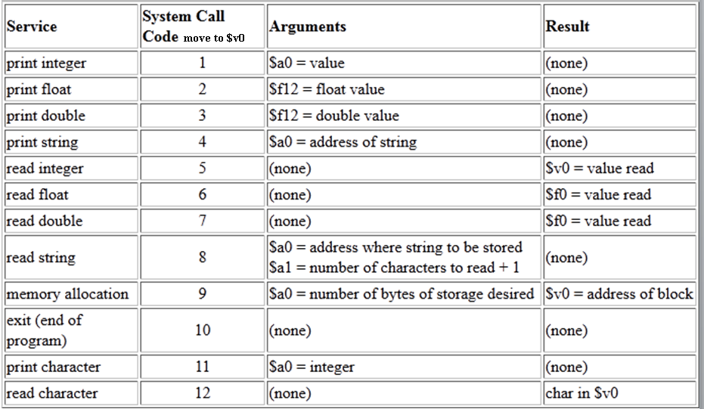
Table 1.2

Getting input from user
li $v0, 5 # Call code for input is 5
syscall # make the syscall.
move $t0, $v0 # Value is read in $v0 by syscall

Displaying value in $t4
li $a0, $t4 # Because argument should be in $a0
li $v0, 1 # Call code for displaying integer is 1
syscall # make the syscall.

Exit from execution at the end of code
li $v0, 10 # syscall code 10 is for exit.
syscall # make the syscall.

Example code

# Your Name Reg No. Date

# add2.asm-- A program that computes and prints the sum
# of two numbers specified at runtime by the user.
# Registers used:

# $t0 - used to hold the first number.
# $t1 - used to hold the second number.
# $t2 - used to hold the sum of the $t1 and $t2.
# $v0 - syscall parameter and return value.
# $a0 - syscall parameter.

main:
## Get first number from user, put into $t0.
li $v0, 5 # load syscall read_int into $v0.
syscall # make the syscall.
move $t0, $v0 # move the number read into $t0.
## Get second number from user, put into $t1.
li $v0, 5 # load syscall read_int into $v0.
syscall # make the syscall.
move $t1, $v0 # move the number read into $t1.
add $t2, $t0, $t1 # compute the sum.
## Print out $t2.
move $a0, $t2 # move the number to print into $a0.
li $v0, 1 # load syscall print_int into $v0.
syscall # make the syscall
li $v0, 10 # syscall code 10 is for exit.
syscall # make the syscall.
# end of add2.asm.

In Lab
Tasks

- Write a program that takes marks of 10 students and then displays the average.
- Write a program that inputs three 1-digit numbers and combines them to form a 3 digit number. For example input 4, 8 ,7, output=487.
- Write a program that inputs marks of four quizzes and four assignments, each out of 10, and the calculates total marks out of 25. Total quiz marks 15/25 and Assignment marks = 10/25

Note: Make a lab report including the codes (with comments) and MARS screenshot for each code which clearly show the register contents after execution and I/O panel. Place your ‘RegNo_Name_LabNo.doc’ file and .asm files in a folder named ‘RegNo_Name’. Now Zip it and give it Name ‘RegNo_Name_labno’. Send it as an attachment in an email with subject ‘LabNo’ to dilshad.sabir@comsats.edu.pk. Obviously replace ‘Reg’, ‘No’ and ‘Name’ in all these names with their values.

Critical Analysis / Conclusion
(By Student about Learning from the Lab)

Lab Assessment
Pre Lab | /5 | /25
Performance | /5
Results | /5
Viva | /5
Critical Analysis | /5
Instructor Signature and Comments

Lab # 02 Strings and Conditional Execution

Objectives
- Using syscall for character string output
- Conditional Execution using ‘branch’ and ‘jump’ instruction for implementing
  - Loops
  - If – else statements

Pre-Lab

Displaying Strings

Code Syntax for MIPS Assembler:
The code syntax in MIPS simulators is written as separate segments (parts); code and data (for initializing data in different ways). There are assembler directives which helps the assembler to differentiate between code and data. The top-level assembler directives are; .text for code and .data is data.
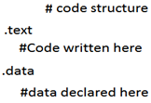
Fig 2.1
The order does not matter here. Data segment can be declared before code segment (.text). Inside .data, data can be defined using any of multiple directives shown in table below.
Note that by default, the assembler starts in the text segment, which is why our earlier programs worked properly even though we didn't explicitly mention which segment to use. In general, however, it is a good idea to include segment directives in your code, and we will do so from this point on.

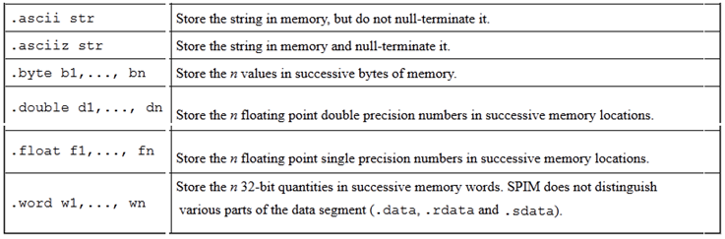
Table 2.1

Example
The code given below displays “Hello World" . In order to display a string, “syscall” is used; but before that, $v0 is loaded with calling code 4 and the address of the string in $a0.
# Name Reg No. Date
# hello.asm-- A "Hello World" program.
# Registers used:
# $v0 - syscall parameter and return value.
# $a0 - syscall parameter-- the string to print.

.text
main:
la $a0, hello_msg # load the addr of hello_msg into $a0.
li $v0, 4 # 4 is the print_string syscall.
Syscall # do the syscall.
li $v0, 10 # 10 is the exit syscall.
Syscall # do the syscall.

# Data for the program:
.data
hello_msg: .asciiz "Hello World\n"

# end hello.asm

Few directives are shown in table 2.1 below
Note that data in the data segment is assembled into adjacent locations. Therefore, there are many ways that we could have declared the string "Hello World\n" and gotten the same exact output. For example we could have written our string as:

.data
hello_msg: .ascii "Hello" # The word "Hello"
.ascii " " # the space.
.ascii "World" # The word "World"
.ascii "\n" # A newline.
.byte 0 # a 0 byte.
If we were in a particularly cryptic mood, we could have also written it as:
.data
hello_msg: .byte 0x48 # hex for ASCII "H"
.byte 0x65 # hex for ASCII "e"
.byte 0x6C # hex for ASCII "l"
.byte 0x6C # hex for ASCII "l"
.byte 0x6F # hex for ASCII "o"
... # and so on...
.byte 0xA # hex for ASCII newline
.byte 0x0 # hex for ASCII NUL

Conditional Execution
Conditional executions such as ‘for loops’ and ‘if-else’ in C, are accomplished in assembly using conditional and unconditional jump statements. Jump statements break the normal sequence of execution and code starts executing from the jump address instead of the next instruction.
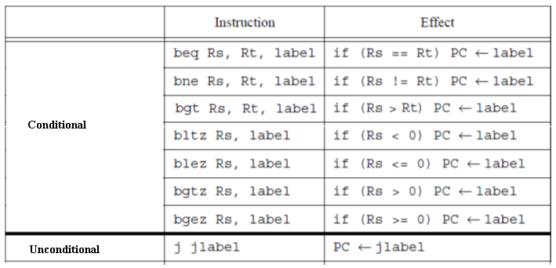

PC stands for ‘program counter’, which hold the address for the next instruction. means if the condition is true, PC will be filled with address of the instruction after ‘label’, instead of the next instruction in sequence.

Loops
Loops are implemented using conditional branch statements, or, with the combination of conditional and unconditional branch statements.

# Name Reg No. Date
# loop1.asm-- A "Loop" program using bne.
# Registers used:
# $v0 - syscall parameter and return value.

.text
#######Loop#########
anylabel:
li $t1,5 #initialize $t1 with 5
li $t0,0 #initialize $t0 with 0

#insert any useful code here

add $t0,$t0,1 #increment counter
bne $t0,$t1,anylabel # Jump back to anylabel while #$t0 < $t1
#################
li $v0, 10 # 10 is the exit syscall.
Syscall # do the syscall.

# Name Reg No. Date
# loop2.asm-- A "Loop" program using beq and j.
# Registers used:
# $v0 - syscall parameter and return value.

.text
########Loop######
anylabel:
li $t1,5 #initialize $t1 with 5
li $t0,0 #initialize $t0 with 0

#insert any useful code here

add $t0,$t0,1 #increment counter
beq $t0,$t1,out # Jump to label out when $t0=$t1
j anylabel #unconditional jump to label

#################
out:
li $v0, 10 # 10 is the exit syscall.
Syscall # do the syscall.

Branching (If – else)
Branching is implemented using combination of conditional and unconditional jump instructions. Example Code given below is (over simplified) grading code. It gets student marks and outputs GPA. It is oversimplified in the sense that it displays
4 when input is greater than or equal to 90
2 when input is greater than 49 and less than 90
0 when input is less than 50

# Name Reg No. Date
# simplegrading.asm-- A grading program
# Registers used:
# $v0 - syscall parameter and return value.
# $t1 – contains input marks
# $t4 – contains output grade

.text
li $t1, 50 #initializing with the marks for comparison
li $t2, 90

li $v0, 5 # Calling Code for integer input (Getting Marks)
syscall
move $t0,$v0 #Move input marks to $t0

bge $t0, $t2, GradeA #If input is greater than 89, jump to label GradeA

bge $t0, $t2, GradeC #If this instruction runs it means Input #is less than 90. Now if input is greater #than 49 jump to label GradeC

li t4, 0 #If two instructions above are not true, it #automatically means marks are less than 50

j bypass_to_end #Unconditional jump to end label bypass #inbetween code

GradeA:
li $t4,4 # Loading with output grade 4

j bypass_to_end

GradeC:
li $t4,2 # Loading with output grade 4

bypass_to_end:

li $v0, 10 # syscall code 10 is for exit.
syscall # make the syscall.

move $a0,$t4 #Moving grade to $a0
li $v0, 1 # Call code for displaying integer is 1
syscall # make the syscall

In-Lab

Tasks
- Write a program that gets a number from user and displays “Even”, or “Odd. (If-else)
- Write a program that input a number from user displays each digit separately. For example if input is 3986, output is 6, 8, 9 ,3. (Loop)
- Write a program that converts a decimal number to binary. (Loop)

Hint for Task 1 and Task 3.
Use, div $tdivident,$tdivider and mfhi $tdestination instructions.

For example,

Div $t1,$t2 will divide $t1 from $t2 and move the quotient to LOW register and remainder to HI register
mfhi $t3 will move remainder from HIGH register to $t3.

Note: Make a lab report including the codes (with comments) and MARS screenshot for each code which clearly show the register contents after execution and I/O panel. Place your ‘RegNo_Name_LabNo.doc’ file and .asm files in a folder named ‘RegNo_Name’. Now Zip it and give it Name ‘RegNo_Name_labno’. Send it as an attachment in an email with subject ‘LabNo’ to dilshad.sabir@comsats.edu.pk. Obviously replace ‘Reg’, ‘No’ and ‘Name’ in all these names with their values.

Critical Analysis / Conclusion
(By Student about Learning from the Lab)

Lab Assessment
Pre Lab | /5 | /25
Performance | /5
Results | /5
Viva | /5
Critical Analysis | /5
Instructor Signature and Comments

Lab # 03 Integer Arithmetic

Objectives
After completing this lab, you will:
- Get familiar with the basic MIPS integer arithmetic and logic instructions including:
  - Integer addition and subtraction instructions
  - Bitwise logic instructions
  - Shift instructions
- Learn some useful applications of these instructions.

Pre-Lab

Integer Add/ Subtract Instructions
The MIPS add/subtract instructions are shown in Table 3.1 below. The R-type add/sub instructions have three registers where the first register is the destination register while the other two registers are the two registers to be added. Similarly, the I-type add/sub instructions have the first register as the destination register, while the second register and the constant are the operands to be either added or subtracted.
Instruction | Meaning
add $s1, $s2, $s3 | $s1 = $s2 + $s3
addu $s1, $s2, $s3 | $s1 = $s2 + $s3
sub $s1, $s2, $s3 | $s1 = $s2 – $s3
subu $s1, $s2, $s3 | $s1 = $s2 – $s3
addi $s1, $s2, 10 | $s1 = $s2 + 10
addiu $s1, $s2, 10 | $s1 = $s2 + 10
Table 3.1: Add/Subtract Instructions
The difference between add/sub and addu/subu instructions is that in case of overflow
occurrence, the add/sub instructions will cause an arithmetic exception and the result will not be written to the destination register. However, for the instructions addu/subu, overflow occurrence is ignored.

As an example of using the add/sub instructions, consider the translation of the expression:

f = (g+h) – (i+j)

Assuming that f, g, h, i, and j are allocated registers $s0 thru $s4, the following assembly code performs the translation:

addu $t0, $s1, $s2 # $t0 = g + h

addu $t1, $s3, $s4 # $t1 = i + j

subu $s0, $t0, $t1 # $s0 = f = (g+h)–(i+j)

To illustrate the use of the addiu instruction with constants, let us assume that variables a, b, and c are allocated in registers $s0, $s1, $s2. Then,

a = b + 5 is translated as: addiu $s0, $s1, 5

c = b – 1 is translated as: addiu $s2, $s1, -1

Hex Addition
EX: |  | ¹8 | ¹A | B
+ |  | B | 7 | 8
= | 1 | 4 | 2 | 3
Review Hex addition covered in detail in CPE241 Digital Logic Design course. Hex addition follows the same rules as decimal addition with the only difference being the added numerals A, B, C, D, E, and F. It may be convenient to have the decimal equivalent values of A through F handy when performing hex operations if the values have not yet been committed to memory. Below is an example of hex addition. Work through the example and refer to the text below it for further details.

Hex addition involves calculating basic decimal addition while converting between hex and decimal when values larger than 9 (the numerals A through F) are present. In the example above, B + 8 in decimal is 11 + 8 = 19. 19_{decimal} is 13_{hex}, since there is 1 set of 16, with 3 left over. Just like in decimal addition, the 1 carries over to the next column. Hence, the next column works out to be 1 + A (10) + 7 = 18_{decimal}, or 12_{hex}. Carry over the 1 to the final column resulting in 1 + 8 + B (11) = 20_{decimal}, or 14hex. This yields the result of 1423_{hex}.

Logical Bitwise Instructions
The MIPS logical instructions are given in Table 3.2. These include the: and, or, nor and xor instructions. The operands for these instructions follow the same convention as the add/sub instructions. The immediate value for the andi, ori, and xori logical instructions is treated as unsigned constant, while it is treated as a signed constant for the addi and addiu instructions.
Instruction |  |  |  | Meaning
and | $s1, | $s2, | $s3 | $s1 | = | $s2 & $s3
or | $s1, | $s2, | $s3 | $s1 | = | $s2 | $s3
xor | $s1, | $s2, | $s3 | $s1 | = | $s2 ^ $s3
nor | $s1, | $s2, | $s3 | $s1 | = | ~($s2|$s3)
andi | $s1, | $s2, | 10 | $s1 | = | $s2 & 10
ori | $s1, | $s2, | 10 | $s1 | = | $s2 | 10
xori | $s1, | $s2, | 10 | $s1 | = | $s2 ^ 10
Table 3.2: Logical Instructions
The and instruction is used to clear bits: x and 0 is equal to 0. The or instruction is used to set bits: x or 1 is equal to 1. The xor instruction is used to toggle bits: x xor 1 is equal to not x. The nor instruction can be used as a not since nor $s1,$s2,$s2 is equivalent to not $s1,$s2. As an example of these instructions, assume that $s1 = 0xabcd1234 and $s2 = 0xffff0000. Then, the following logical instructions produce the shown resulting values in registers $s3 to $s6:

and $s3, $s1,$s2 # $s3 = 0xabcd0000
or $s4, $s1,$s2 # $s4 = 0xffff1234
xor $s5,$s1,$s2 # $s5 = 0x54321234
nor $s6,$s1,$s2 # $s6 = 0x0000edcb
The sample program to run this code is given below.

.text
.globl main
main: # main program
li $s1, 0xabcd1234 # Pseudo instruction to initialize a register
li $s2, 0xffff0000
and $s3,$s1,$s2 # $s3 = 0xabcd0000
or $s4,$s1,$s2 # $s4 = 0xffff1234
xor $s5,$s1,$s2 # $s5 = 0x54321234
nor $s6,$s1,$s2 # $s6 = 0x0000edcb
li $v0, 10 # Exit program
syscall
The and instruction can be used for masking bits in a word. This instruction is useful in cases where you want to clear some bits and leave other unchanged. Remember the following example from the class:
and $t0, $t1, $t2 # $t1 is the “AND mask”

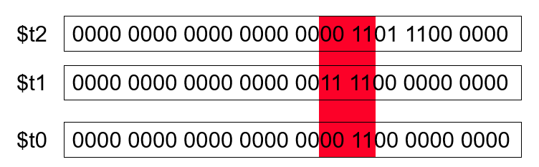

Arithmetic and logic instructions have many useful applications. For example, to convert a
character in register $s0 from lower case (i.e. 'a' to 'z') to upper case (i.e. 'A' to 'Z'), we could
use any of the following instructions:

subi $s0, $s0, 0x20 # ASCII code of 'a' = 0x61, of 'A' = 0x41
andi $s0, $s0, 0xfd

Similarly, to convert a character in register $s0 from upper case to lower case, we could use any of the following instructions:

addi $s0, $s0, 0x20
ori $s0, $s0, 0x20

To initialize the content of register $s0 by a 16-bit constant k (i.e., having a value in the range 0 to 2¹⁵-1), we can use any of the following instructions:

addi $s0, $0, k
ori $s0, $0, k

However, to initialize a register with a 32-bit constant, we need to use the lui instruction.
Suppose that we want to initialize $s1 with the constant 0xAC5165D9 (32-bit constant), then we
can use the following two instructions:
load upper 16 bits | clear lower 16 bits
0xAC51 | 0x0000

lui $s1, 0xAC51 $s1=$17
0xAC51 | 0x65D9

ori $s1, $s1, 0x65D9 $s1=$17

This sequence of instructions is generated by the assembler when we use the pseudo instruction:
li $s1, 0xAC5165D9

Shift Instructions
The MIPS shift instructions are given in Table 3.3. The first operand of the shift instructions is the destination register; the second operand is the register to be shifted while the third operand specifies the amount of shift. The amount of shift can be specified as a constant value or it can be stored in a register. For the instructions sll, srl, sra, the shift amount is a 5-bit constant while for the instructions sllv, srlv, srav, the shift amount is variable and is stored in a register.

Instruction |  | Meaning
sll | $s1,$s2,10 | $s1 | = | $s2 << 10
srl | $s1,$s2,10 | $s1 | = | $s2>>>10
sra | $s1,$s2,10 | $s1 | = | $s2 >> 10
sllv | $s1,$s2,$s3 | $s1 | = | $s2 << $s3
srlv | $s1,$s2,$s3 | $s1 | = | $s2>>>$s3
srav | $s1,$s2,$s3 | $s1 | = | $s2 >> $s3
Table 3.3: Shift Instructions.
Shifting is to move all the bits in a register left or right. sll/srl mean shift left/right logical while sra means shift right arithmetic for which the sign-bit (rather than 0) is shifted from the left as illustrated in Figure 3.1.
As an example, let us assume that $s2 = 0xabcd1234 and $s3 = 16. Then, the following shift instructions produce the shown values in $s1.
sll $s1,$s2,8 #$s1 = $s2<<8 $s1 = 0xcd123400
sra $s1,$s2,4 #$s1 = $s2>>4 $s1 = 0xfabcd123
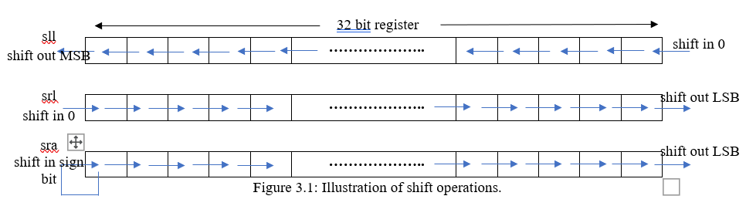
srlv $s1,$s2,$s3 #$s1 $s2>>>$s3 $s1 = 0x0000abcd

We can use shift instructions along with either addition or subtraction instructions to multiply the content of a register by a constant. Shift-left (sll) instruction can be used to perform multiplication when the multiplier is a power of 2. You can factor any binary number into powers of 2. For example, to multiply $s1 by 36, factor 36 into (4 + 32) and use distributive property of multiplication $s2 = $s1*36 = $s1*(4 + 32) = $s1*4 + $s1*32. Thus, this can be achieved by the following instructions:
sll $t0, $s1, 2 # $t0 = $s1 * 4
sll $t1, $s1, 5 # $t1 = $s1 * 32
addu $s2, $t0, $t1 # $s2 = $s1 * 36
As another example, let us multiply the content of $s1 by 31. We can do that using the following
instructions noting that 31=32-1:
sll $s2, $s1, 5 # $s2 = $s1 * 32
subu $s2, $s2, $s1 # $s2 = $s1 * 31
We can also use the shift right instructions (srl and sra) to divide a number by a power of 2 constant. Shifting register $s0 right by n bits divides its content by 2n. For example, to divide an unsigned number in register $s0 by 8, we use the instruction srl $s0, 3. However, to divide a signed number in register $s0 by 8, we use the instruction sra $s0, 3.

In-Lab

Tasks
- Write a program to ask the user to enter two integers A and B and then display the result of computing the expression: A + 2B - 5.
- 2. Assume that $s1 = 0x12345678 and $s2 = 0xffff9a00. Determine the content of registers $s3 to $s6 after executing the following instructions:
and $s3, $s1, $s2 # $s3 =
or $s4, $s1, $s2 # $s4 =
xor $s5, $s1, $s2 # $s5 =
nor $s6, $s1, $s2 # $s6 =
Write a program to execute these instructions and verify the content of registers $s3 to $s6.
- Assume that $s1 = 0x87654321. Determine the content of registers $s2 to $s4 after executing the following instructions:
sll $s2, $s1, 16 # $s2 =
srl $s3, $s1, 8 # $s3 =
sra $s4, $s1, 12 # $s4 =
Write a program to execute these instructions and verify the content of registers $s2 to $s4.
- Write a program that asks the user to enter an alphabetic character (either lower or upper case) and change the case of the character from lower to upper and from upper to lower and display it.
- Write a program that asks the user to enter and integer number and read it. Then ask him to enter a bit position (between 0 and 31) and display the value of that bit.
- Write a program that asks the user to enter a signed number and read it. Then display the content of multiplying this number by 24.

Note: Make a lab report including the codes (with comments) and MARS screenshot for each code which clearly show the register contents after execution and I/O panel. Place your ‘RegNo_Name_LabNo.doc’ file and .asm files in a folder named ‘RegNo_Name’. Now Zip it and give it Name ‘RegNo_Name_labno’. Send it as an attachment in an email with subject ‘LabNo’ to dilshad.sabir@comsats.edu.pk. Obviously replace ‘Reg’, ‘No’ and ‘Name’ in all these names with their values.

Critical Analysis / Conclusion
(By Student about Learning from the Lab)

Lab Assessment
Pre Lab | /5 | /25
Performance | /5
Results | /5
Viva | /5
Critical Analysis | /5
Instructor Signature and Comments

Lab # 04 Flow Control

Objectives
After completing this lab, you will:
- Get familiar with MIPS Jump and Branch instructions.
- Learn about pseudo instructions in MIPS.
- Learn how to translate high-level flow control constructs (if-then-else, for loop, while loop) to MIPS code.

Pre-Lab

MIPS Jump and Branch Instructions
Like all processors, MIPS has instructions for implementing unconditional and conditional jumps. The MIPS Jump and Branch instructions are shown in Table 4.1.

Instruction | Meaning | Format
j Label | jump to label | op⁶ = 2 | imm²⁶
beq rs, rt, label | branch if (rs==rt) | op⁶ = 4 | rs⁵ | rt⁵ | imm¹⁶
bne rs, rt, label | branch if (rs!=rt) | op⁶ = 5 | rs⁵ | rt⁵ | imm¹⁶
blez rs, label | branch if (rs<=0) | op⁶ = 6 | rs⁵ | 0 | imm¹⁶
bgtz rs, label | branch if (rs>0) | op⁶ = 7 | rs⁵ | 0 | imm¹⁶
bltz rs, label | branch if (rs<0) | op⁶ = 1 | rs⁵ | 0 | imm¹⁶
bgez rs, label | branch if (rs>=0) | op⁶ = 1 | rs⁵ | 1 | imm¹⁶
Table 4.1: MIPS Jump and Branch Instructions.

For unconditional jump, the instruction j label is used where label is the address of the target instruction as shown below:

j label # jump to label

. . .

label:

There are two MIPS conditional branch instructions that branch based on the condition whether two registers are equal or not as follows:

beq Rs, Rt, label # branch to label if (Rs == Rt)

bne Rs, Rt, label # branch to label if (Rs != Rt)

Four additional MIPS instructions are provided based on comparing the content of a register with 0 as follows:

bltz Rs, label # branch to label if (Rs < 0)

bgtz Rs, label # branch to label if (Rs > 0)

blez Rs, label # branch to label if (Rs <= 0)

bgez Rs, label # branch to label if (Rs >= 0)

Note that MIPS does not provide the instructions beqz and bnez as these can be implemented using the beq and bne instructions with register $0 used as the second operand.

MIPS also provides four set on less than instructions as follows:

slt rd, rs, rt # if (rs < rt) rd = 1 else rd = 0

sltu rd, rs, rt # unsigned <

slti rt, rs, im16 # if (rs < im16) rt = 1 else rt = 0

sltiu rt, rs, im16 # unsigned <

Note that the instructions slt and slti are used for signed comparison while instructions sltu and sltiu are used for unsigned comparison.

Pseudo Instructions

Pseudo instructions are instructions introduced by an assembler as if they were real instructions. We have seen an example of a pseudo instruction before, which is the li instruction. Pseudo instructions are useful as they facilitate programming in assembly language.

For example, the MIPS processor does not have the following useful conditional branch comparison instructions:
blt, bltu branch if less than (signed/unsigned)
ble, bleu branch if less or equal (signed/unsigned)
bgt, bgtu branch if greater than (signed/unsigned)
bge, bgeu branch if greater or equal (signed/unsigned)
The reason for not implementing these instructions as part of the MIPS instruction set is that they can be easily implemented based on a set of two instructions.
For example, the instruction blt $s0, $s1, label can be implemented using the following sequence of two instructions:
slt $at, $s0, $s1
bne $at, $zero, label

Similarly, the instruction ble $s2, $s3, label can be implemented using the following sequence of two instructions:
slt $at, $s3, $s2
beq $at, $zero, label

Table 4.2 shows more examples of pseudo instructions. Note that the assembler temporary register $at=$1 is reserved for its own use.

Instruction |  |  |  | Meaning
move | $s1, | $s2 |  | addu $s1, $zero, $s2
not | $s1, | $s2 |  | nor $s1, Ss2, $zero
li | $s1, | 0xabcd |  | ori $s1, $zero, 0xabcd
li | $s1, | 0xabcd1234 |  | lui $at, 0xabcd  ori $s1, $at, 0x1234
sgt | $s1, | $s2, | $s3 | slt $s1, $s3, $s2
blt | $s1, | $s2, | label | slt $at, $s1, $s2  bne $at, $zero, label
Table 4.2: Examples of pseudo instructions.

Translating High Level Flow Control Constructs to MIPS Assembly
We can translate any high-level flow construct into assembly language using the jump, branch and set-less-than instructions. For example, let us consider the following if statement:
if (a == b) c = d + e; else c = d – e;

Let us assume that variables a, b, c, d, e are stored in registers $s0 thru $s4 respectively. The following assembly code implements this IF statement:
bne $s0, $s1, else
addu $s2, $s3, $s4
j exit
else: subu $s2, $s3, $s4
exit: . . .
We can also implement an IF statement with a compound condition involving logical AND operation. For example, let us consider implementing the following IF statement:
if (($s1 > 0) && ($s2 < 0)) {$s3++;}
The IF statement is implemented efficiently using the following assembly code which uses the fall through concept which skips the execution of the instruction if the first condition is false otherwise it continues the execution:
blez $s1, next # skip if false
bgez $s2, next # skip if false
addiu $s3, $s3, 1 # both are true
next:
We can also implement all types of loops. Let us consider implementing the following for loop:
for (i=0; i<n; i++) {
loop body
}
Let us assume that variable i is stored in register $s0 and n is stored in register $s1. Then, the for loop is implemented using the following assembly code:
li $s0, 0 # i = 0
ForLoop:
bge $s0, $s1, EndFor
loop body
addi $s0, $s0, 1 # i++
j ForLoop
EndFor:
Consider the implementing of the following while loop:
i=0;
while (i<n) {
loop body
i++;
}
We can note that this while loop has identical behavior to the for loop and hence its assembly
code will be identical.
Finally, let us consider implementing the following do-while loop:
i=0;
do {
loop body
i++;
} while (i<n)
The do-while loop can be translated using the following assembly code:
li $s0, 0 # i = 0
WhileLoop:
loop body
addi $s0, $s0, 1 # i++
blt $s0, $s1, WhileLoop

In-Lab

Tasks
- Write a program that asks the user to enter an integer and then displays the number of 1's in the binary representation of that integer. For example, if the user enters 9, then the program should display 2.

- Write a program that asks the user to enter two integers: n1 and n2 and prints the sum of all numbers from n1 to n2. For example, if the user enters n1=3 and n2=7, then the program should display the sum as 25.

- The Fibonacci sequence are the numbers in the following integer sequence: 0, 1, 1, 2, 3, 5, 8, 13, 21, 34, 55, 89, 144, ...
The first two numbers are 0 and 1 and each subsequent number is the sum of the previous two. Write a program that asks the user to enter a positive integer number n and then prints the nth number in the Fibonacci sequence. The following algorithm can be used:
/* Input: n positive integer
Output: nth Fibonacci number
fib0 = 0, fib1 = 1 */
for (i=2; i <= n; i++) do
temp = fib0
fib0 = fib1
fib1 = temp + fib1
if (n > 0) fib = fib1
else fib = 0

Note: Make a lab report including the codes (with comments) and MARS screenshot for each code which clearly show the register contents after execution and I/O panel. Place your ‘RegNo_Name_LabNo.doc’ file and .asm files in a folder named ‘RegNo_Name’. Now Zip it and give it Name ‘RegNo_Name_labno’. Send it as an attachment in an email with subject ‘LabNo’ to dilshad.sabir@comsats.edu.pk. Obviously replace ‘Reg’, ‘No’ and ‘Name’ in all these names with their values.

Critical Analysis / Conclusion
(By Student about Learning from the Lab)

Lab Assessment
Pre Lab | /5 | /25
Performance | /5
Results | /5
Viva | /5
Critical Analysis | /5
Instructor Signature and Comments

Lab # 05 Introduction to Verilog HDL Combinational Circuits 1

Objectives
- Gate Level Modeling

Pre-Lab

Verilog

About Verilog
Verilog HDL is a programming language used to describe a digital system: for example, a network switch, a microprocessor or a memory or a simple flip-flop. This just means that, by using a HDL, one can describe any (digital) hardware at any level.

Design Methodologies
There are two basic types of digital design methodologies: a top-down design methodology and a bottom-up design methodology

Top-Down Design Methodology
In a top-down design methodology, we define the top-level block and identify the sub-blocks necessary to build the top-level block. We further subdivide the sub-blocks until we come to leaf cells, which are the cells that cannot further be divided

Bottom-up Design Methodology
In a bottom-up design methodology, we first identify the building blocks that are available to us. We build bigger cells, using these building blocks. These cells are then used for higher-level blocks until we build the top-level block in the design. In a bottom-up design methodology, we first identify the building blocks that are available to us. We build bigger cells, using these building blocks. These cells are then used for higher-level blocks until we build the top-level block in the design

Abstraction Level
Verilog descriptions can span multiple levels of abstraction i.e. levels of detail, to describe a digital system and can be used for different purposes at various stages in the design process.
Following are different abstraction levels:
- Switch Level (Transistor Level)
- Gate Level (AND, OR gates etc.)
- Boolean Equation Level (Continuous Assignment)
- Behavioral Level
    - Procedural Assignment or Blocking Assignment (Combinational Circuits)
    - Register Transfer Level or Non-Blocking Assignment (Sequential Circuits)
    - Algorithmic (Combination & Sequential). Not Necessarily Synthesizable

In this lab we will practice Gate Level and Continuous Assignment. Both have one thing in common, i.e. the detail of the circuit should already be known before using these two abstraction levels. In the next lab we will use an abstraction level where only the relationship between input and output is described, and the circuit is synthesized by the synthesis tool (software).

Writing Code

Code Structure
Verilog code is a written as a module and its test bench. Module represent block of digital circuit performing the desired functionality. It has input and output ports, written along with its declaration. A test bench is used to test the module by providing an input and checking the corresponding output.

Module
A module is the basic building block in Verilog. A module can be an element or a collection of lower-level design blocks. Typically, elements are grouped into modules to provide common functionality that is used at many places in the design. A module provides the necessary functionality to the higher-level block through its port interface (inputs and outputs), but hides the internal implementation.

module my_design (module_ports);
// Declarations of ports go here
// Functional details go here
endmodule
The mode of a module port (input or output) is not determined by the order in which it appears in the list (as opposed to primitives). Its mode is defined inside the module

module my_half_adder(sum, c_out, a, b);

output sum, c_out;
input a,b;

xor M1(sum, a, b); //Instantiating primitive XOR
and M2(c_out, a, b);//Instantiating primitive AND
//Any instance name can be //given. M1 and M2 are not //keywords. You may use your //name

endmodule

Testbench

In order to test the module written, there should be a mechanism to supply input to the input ports and then check the result at the output ports of module. A testbench, which is also a code (module) written in verilog, provides this functionality.
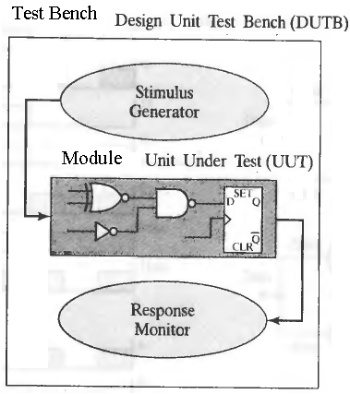
Figure 4.1
A testbench module doesn’t have any inputs and outputs. The desired module to be tested is instantiated inside it, just as the primitives(XOR & AND gates) were instantiated in our previous code. Before instantiating the module variables need to be defined. Variables which have the task of acting as a stimulus are declared as type reg, while the ones that are used to check the response are declared as type wire.
In order to test the module the stimulus (reg variables) should be given different values during testing period. This is accomplished by a single-pass Verilog behavior, declared by the keyword initial and accompanied by statements. It is enclosed by the block statement keyword pair begin and end if there are more than 1 instructions in the behavior.

module test_my_half_adder;
wire sum, c_out; //Outputs of UUT (in this case
// ‘module my_half_adder’) declared as //wire
reg a, b; // Inputs of UUT declared as ‘reg‘

my_half_adder AA(sum, c_out, a, b); //Instantiating
//UUT

initial //Simulation will end
#100 $finish; // at 100ns

initial begin //Initially a=x, b=x
#10 a = 0; b = 0; //After 10ns a=0, b=0
#l0 b = 1; //After 20ns a=0, b=1
#10 a = 1; //After 30ns a=1, b=1
#l0 b = 0; //After 40ns a=1, b=0
end
endmodule
A testbench can have multiple initial behaviors which run in parallel. For example the testbench given above can be modified as
module test_my_half_adder;
wire sum, c_out; //Outputs of UUT (in this case
// ‘module my_half_adder’) declared as //wire
reg a, b; // Inputs of UUT declared as ‘reg‘

my_half_adder AA(sum, c_out, a, b); //Instantiating
//UUT

initial begin //Simulation will end
#100 $finish; // at 100ns
end

initial begin //Initially a=x, b=x
#10 a = 0; //After 10ns a=0

#20 a = 1; //After 30ns a=1

end

initial begin //Initially a=x, b=x
#10 b = 0; //After 10ns b=0
#l0 b = 1; //After 20ns b=1
#20 b = 0; //After 40ns a=1, b=0
end

endmodule

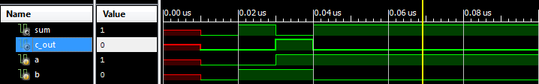
Fig 4.2 (Testbench output)

Ports and Nets
The input and output ports are declared by the keywords input and output. A vector (more than 1 bit) is declared by enclosing the size in square brackets. For example a 4-bit input ‘a’ is declared by input [3:0] a;. The individual bits in a vector can be excessed. For example a[2:1] will select 2nd and 3rd bit from the 4-bit vector a[3:0].
For a multilayer circuit the intermediate connecting wires (nets) are declared by the keyword wire.

Verilog uses a four-valued logic system having the symbols: 0, 1, x, and z. The value x represents a condition of ambiguity in which the simulator cannot determine whether the value of the signal is 0 or 1. This happens, for example, when a net is driven by two primitives that have opposing output values. The logic value z denotes a condition in which a wire is disconnected from its driver.

Primitives
Verilog has built in primitives like gates which are fundamental in gate level simulation. These have n-inputs and single output.
AND Gate | and(y,x₁,x₂,……,x_{n})
OR Gate | or(y,x₁,x₂,……,x_{n})
NAND Gate | nand(y,x₁,x₂,……,x_{n})
NOR Gate | nor(y,x₁,x₂,……,x_{n})
XORGate | xor(y,x₁,x₂,……,x_{n})
XNOR Gate | xnor(y,x₁,x₂,……,x_{n})

NOT gate has just one input ; not(y,x). Note that in primitives output is always written first in the arguments. However in a user defined module, any order is allowed.

Instantiating user-defined Module
A module can instantiate another smaller module in it. This approach is convenient when coding large systems. For example, a Full Adder module (which has three inputs) can be written by just connecting two Half Adder Modules.
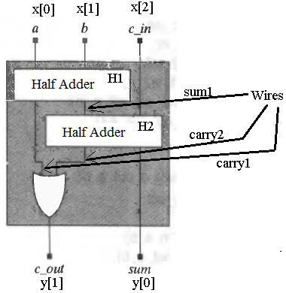

Fig 4.3

module my_full_adder(input [2:0] x, output [1:0] y);
//Different style + use of vectors
// x is 3-bit input & y is 2-bit output ,sum and carry;
wire sum1,carry1,carry2;
my_half_adder H1(sum1, carry1, x[0], x[1]);
my_half_adder H2(y[0], carry2, sum1, x[3]);
or (y[1],carry1,carry2);
endmodule

Write the testbench yourself.

Modelsim
ModelSim ME HDL Simulator is a source-level verification tool, allowing you to verify HDL code line by line. You can perform simulation at all levels.
- In order to use it for simulation create a project first.
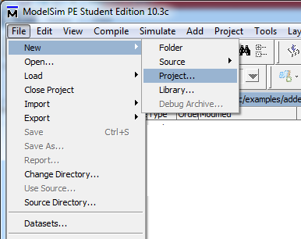
Figure 4.2

- Give it any name
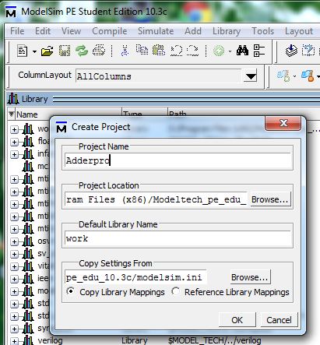
Figure 4.3

- If you have already witten the code of adder and testbench given above (and saved it with .v extension) click ‘Add Existing File’, otherwise choose ‘Create New File’. You can write both the adder and testbench in the same file

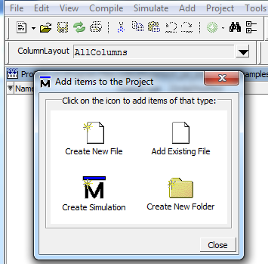
Figure 4.4

- If you are creating new file choose Verilog as file type and give its any name of your choice.
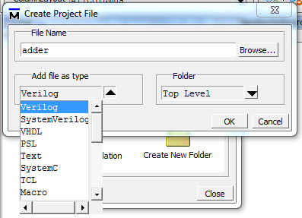
Figure 4.5

- After adding the files containing the complete code, compile them.
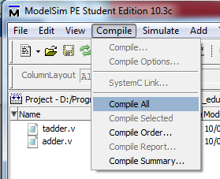
Figure 4.6

- If the compilation completed without errors start simulation

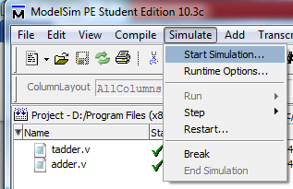
Figure 4.7

- In the ‘Start Simulation’ window expand ‘work’ and select your testbench module which in this case is test_my_half_adder, and click OK.
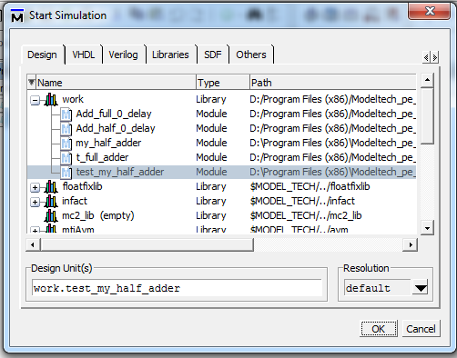
Figure 4.8

- Now from the object panel select signals, right click and select ‘Add Wave’.

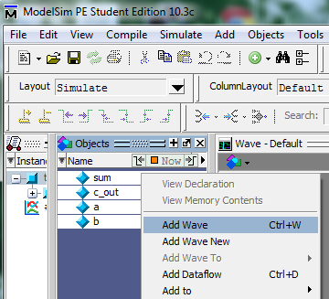
Figure 4.9

- Finally click Run100 as shown in figure below.
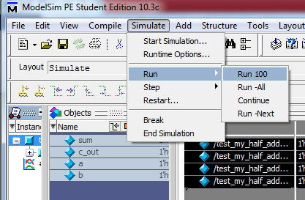
Figure 4.10

- Now analyze the signals and check if the module half adder is working correctly.

Figure 4.11

In-Lab

Tasks (Use Xilinx)
(Define input and output as vectors ; and not multiple variables)
- Write the Verilog gate-level description and testbench for a circuit with 3-bit input(X) and 1-bit output (Y). The output is 1 if the input number is a palindrome (reads the same backward and forward eg 101 or 010). The minterms of the output will be.. (hint: by gate level not using assignment operator).
module palindrome(input [2:0]x,output y);
Y(X₂,X₁,X₀) = ∑(0,2,5,7) i.e. 000,010,101 and 111

- Write the Verilog gate-level description and testbench for a circuit with 6-bit input(X) and 1-bit output (Y). It compares the first three bits of the inputs with the latter three and sets output equal to 1 when both are equal.
Y=X₀*X₃ + X₁*X₄ ₊ X₂*X₅

- Write the Verilog gate-level description and testbench for a circuit with 6-bit input(X) and 1-bit output (Y). It compares the first three bits of the inputs with the latter three and sets output equal to 1 when both are mirror image. For example 100 001 or 110 011
Y=X₀*X₅ + X₁*X₄ ₊ X₂*X₃

- Your lab report must comprise of two things; a .doc file and separate .v files for each code
- The .doc file must have a title page having your name, reg number and submission date written on it.
- The .doc file should have code (with comments) and screen shots of waveforms and schematic.
  - Note: Screen shots of waveforms(cropped) as shown in figure 4.2

Critical Analysis / Conclusion
(By Student about Learning from the Lab)

Lab Assessment
Pre Lab | /5 | /25
Performance | /5
Results | /5
Viva | /5
Critical Analysis | /5
Instructor Signature and Comments

Lab # 06 Combinational and Sequential circuits

Objectives

This lab includes a refresher of combinational and sequential circuits.
- Review/refresher of combinational circuits.
- Review/refresher of sequential circuits.

Pre-Lab

Combinational Circuits
Continuous assignments provide a way of modeling combinational logic at a higher level of abstraction than Gate-Level logic. It allows the use of Boolean logic rather than gate connections. The left-hand side of an assignment is a variable to which the right-side value is to be assigned and must be a net. The right-hand side of an assignment, separated from the left-hand side by the equal (=) character, can be a net, a reg or any expression that evaluates a value including function calls. Continuous assignments are always active and assignments occur whenever the right-hand side operands changes. It drives both vector and scalar.

Operators
Function | Operator
NOT | ~
AND | &
OR | |
XOR | ^
XNOR | ~^ or ^~
Table 6.1 (Bitwise operators)

The code example explains these

.
Function | Operator
Left Shift | <<
Right Shift | >>
Table 6.2 (Bit Shifting)

a>>2 will right shift ‘a’ by 2 bits.
Function | Operator
Concatenation | { }
Table 6.3 (Concatenation)
Concatenation is used to merge multiple variables. For example if ‘a’ is 8-bit variable ‘b’ is 16-bit variable {a , b[3:0], 4’b1001’} results in 16-bit value.

Function | Operator
Conditional operation | ? :
Table 6.4 (Conditional Execution)

Conditional operator is used to implement a circuit using if-else like structure

Example
The code for Fig 6.1 using continuous assignment is given below.

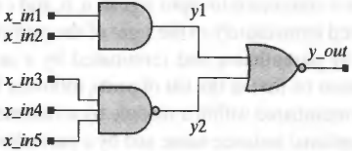
Fig 6.1(five-input and-or-invert (AOI) circuit)
This circuit can be implemented using a single assign statement
module AOI5_CA0 (y_out, x_in);
input [4:0] x_in;
output y_out;
assign y_out = ~((x_in[0] & x_in[1])|(x_in[2]& x_in[3]& x_in[4]));
endmodule
~ means inversion (Not gate), | is Or, and & is And gate.
The module AOI5_CA0 can also be written using multiple continuous assignments

module AOI5_CA3 (y_out, x_in1, x_in2, xin_3, xin_4, xin_5);
input x_in1, x_in2, x_in3, x_in4,x_in5;
output y_out;
wire y1 = x_in[0] & x_in[1] & x_in[4]; // Bitwise and operation
wire y2 = xin_[2] & xin_[3];
assign y_out = ~(y1 | y2); // Complement the result of bitwise OR //operation
endmodule

Conditional operator
Conditional operator can be used to implement enables
The five-input AOI circuit can be modified to have an additional input, enable, and to have a three-state output, as described by AOC5_CAI below.
module AOC5_CA1 (y_out, x_in1, x_in2, x_in3, x_in4, x_in5, enable);
input x_in1, x_in2, x_in3, x_in4, x_in5, enable;
output y_out;
assign y_out = enable? ~((x_in1 & x_in2)|(x_in3 & x_in4 & x_in5)): 1'bz;
endmodule
The conditional operator (? :) acts like a software if-then-else switch that selects between two expressions. In the above example, the conditional execution stement means,
if enable == 1
y_out=~((x_in1 & x_in2)|(x_in3 & x_in4 & x_in5))
else
y_out= 1’bz;
Example code given below implements a 32-bit 4-1 mux using conditional operator.
Input [31:0] input0, input1, input2, input3;
output [31:0] muxout;
input [1:0] select;
assign muxout = (select == 2'b00) ? input0:
( (select == 2'b01) ? input1 :
( (select == 2'b10) ? input2 :
( (select == 2'b11) ? input3 : 32’bz )))
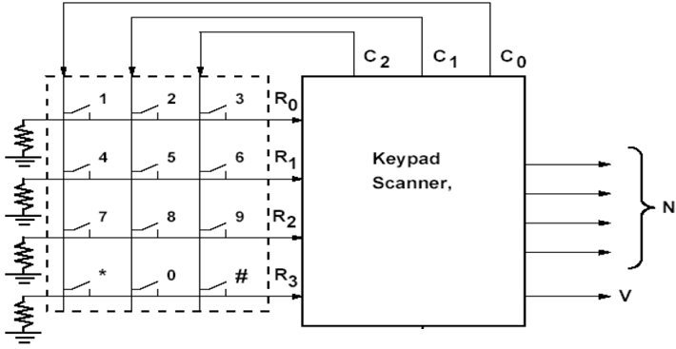

The row vector (R3-R0) selects the row the number, while column vector (C2-C0) tells the column. For example, for number 5 (0101₂) R1=1 and C1=1, all others are zero. If more than one row or column inputs are equal to1, v=0. Also if all the inputs are zero v=0.
Working principle can be understood with the few examples below

R3 | R2 | R1 | R0 | C2 | C1 | C0 | N3 | N2 | N1 | N0 | V
0 | 0 | 0 | 0 | 0 | 0 | 0 | 0 | 0 | 0 | 0 | 0
0 | 0 | 0 | 1 | 0 | 0 | 1 | 0 | 0 | 0 | 1 | 1
0 | 0 | 0 | 1 | 0 | 1 | 0 | 0 | 0 | 1 | 0 | 1
0 | 0 | 0 | 1 | 1 | 0 | 0 | 0 | 0 | 1 | 1 | 1
0 | 1 | 0 | 0 | 0 | 0 | 1 | 1 | 0 | 0 | 1 | 1

Sequential Circuits
A synchronous circuit consists of two kinds of elements: registers and combinational logic. Figure 8.1 shows the generic form of a sequential circuit. The brown colored signal depends on the type of machine. It is only present for a Mealy-type circuit. For a Moore-type circuit, it is absent.

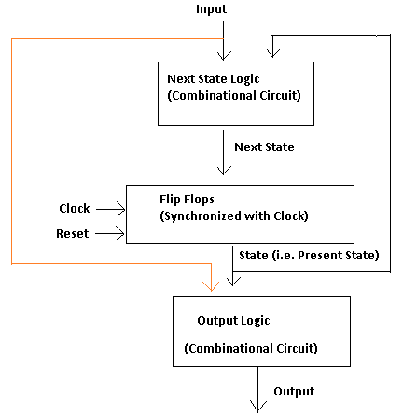
Figure 8.1

Hardware Description

Combinational Part
The two combinational circuits (Next State Logic & Output Logic) can be described using any of the techniques studied in earlier labs i.e. gate level modeling, continuous assignment or procedural assignment inside cyclic behaviors (always @). Recommended method is cyclic behaviors.

Sequential Part
The clocked part of the circuit is described using RTL modeling inside cyclic behaviors. It is almost similar to the topic studied in the previous lab. The differences are
- Inside the sensitivity list @ posedge clock is used. It means that the assignments written inside the cyclic behavior will only execute when clock changes from 0 to 1
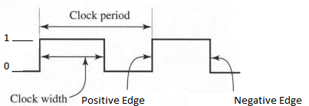

Figure 8.2(Clock Signal)

- Non-Blocking assignment operator (<=) is used. All the assignments written using <= execute in parallel so the order in which they are listed has no effect.
For example, if a=1, b=2, c=3
b=c
a=b will result in a=c=3
but
b<=c
a<=b will result in b=3, a=2
- Reset signal is compulsory for the sequential part and there are different modes of reset
  - Synchronous Reset (Synchronized with clock)
always @ ( posedge clk)
begin
if(reset)
//reset the Flipflops
else
//do required task
end
  - Asynchronous Reset
    - Edge Triggered
always @ ( posedge clk or negedge reset)
begin
if(reset==0)
//reset the Flipflops
else
//do required task
end
Level Triggered
always @ ( posedge clk or reset)
begin
if(reset==1)
//reset the Flipflops
else
//do required task
end

Code Example
Given below is the state diagram of a Mealy Machine
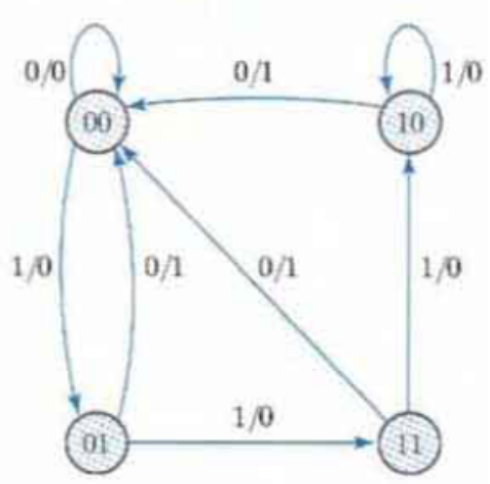
Figure 8.3
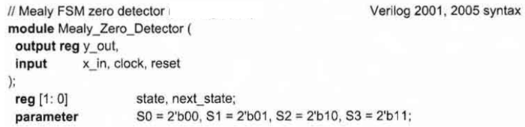

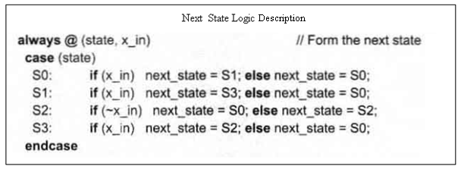
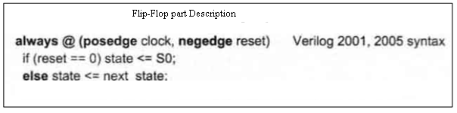

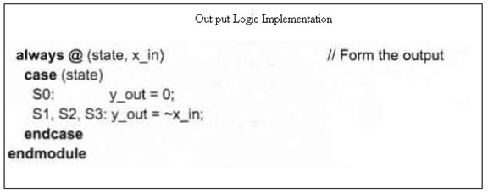

Clock Generators for Testbench
Clock generators are used in testbenches to provide a clock signal for testing the model of a synchronous circuit. The forever loop causes unconditional repetitive execution of statements, subject to the disable statement, and is a convenient construct for describing clocks. You will have to add the following two single-pass behaviors to your testbench to generate clock signal.
reg clock;
parameter half_cycle = 50;
parameter stop_time = 350;
initial
begin: clock_loop // Note: clock_loop is a named block of //statements
clock = 0;
forever
begin
#half_cycle clock = 1;
#half_cycle clock = 0;
end
end

initial
#stop_time disable clock_loop;

In-Lab

Tasks
- Implement the circuit for a keypad scanner using continuous assignment. Use the keypad information given in the pre-lab to implement your design.
- Write the Verilog HDL description for a circuit that keeps on taking 1’bit input serially and outputs ‘1’ when the no of 1’s in the input stream is even.

- Your Lab report should contain screenshots of waveforms
- Send separate .v (project) files for each task as well.
- Place your RegNo_Name_LabNo.doc file and .v files in a folder named RegNo_Name. Now Zip it and give it Name RegNo_Name. Send it as an attachment in an email with subject LabNo to dilshad.sabir@comsats.edu.pk. Obviously replace ‘Reg’, ‘No’ and ‘Name’ in all these names with their values.

Critical Analysis / Conclusion
(By Student about Learning from the Lab)

Lab Assessment
Pre Lab | /5 | /25
Performance | /5
Results | /5
Viva | /5
Critical Analysis | /5
Instructor Signature and Comments

Lab # 07 Implementation and Simulation of the Instruction Fetch Module of MIPS

(Single Cycle Datapath)

Objectives
After completing this lab, you will implement, simulate and understand:
- The Instruction Fetch datapath of the Single Cycle MIPS Processor

Pre-Lab
For the next few labs, our task is to implement the MIPS single cycle datapath as shown in the figure below. It will take more than one lab. MIPS has 32 registers each 32-bit wide. The instruction size is 32-bit too.
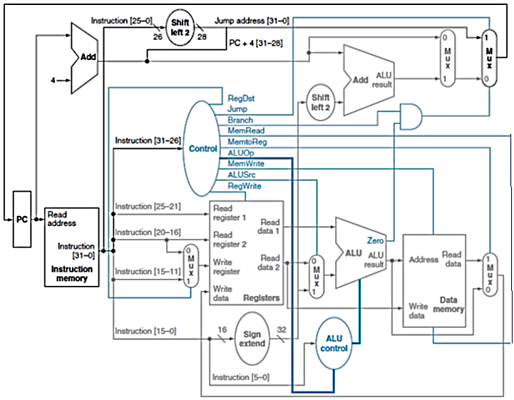
Figure 7.1 MIPS Single Cycle datapath and control.

Building the Datapath
The first thing that we need to build the datapath is an instruction memory and a mechanism to get new instruction on each clock cycle. The mechanism can be constructed using PC (Program Counter) and an adder. PC is a 32-bit register which holds the address of the next instruction and the adder increments PC on each clock cycle so that it points to the next instruction. Write (three) separate modules for each of these.

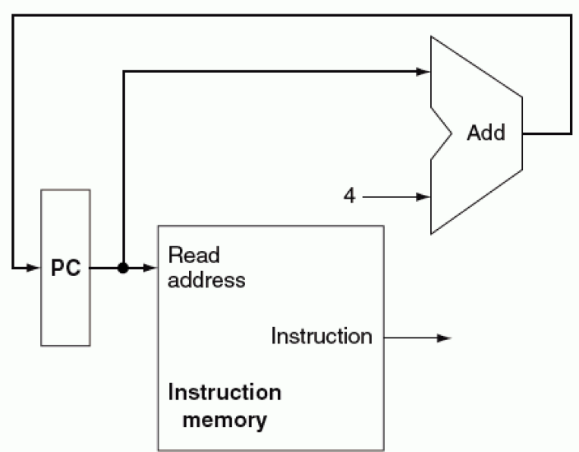
Figure 7.1: MIPS instruction fetch datapath.
You must be already familiar with implementation of a register with clock and reset signals, and an adder in Verilog. For instruction memory implementation, please read the next section.

Memories in Verilog
In general, the structure defined in this section can be used to implement the register file, instruction as well as the data memory.
Declaring Memory
In order to implement a Memory unit you will have to use an array of vectors.
reg [n-1:0] anyname [m-1:0];//Declaring m registers, each n-bit //wide.
For example in order to declare 8 registers each 32-bit wide, the statements used should be,
reg [31:0] reg_array [7:0];
In order to move the 6th word (1 word=32bits) of reg_file in another 32-bit signal ‘b’, the following statement used should be
b= reg_file[5]
Output Mechanism
Data is read from memory asynchronously (independent of clock). It can be accomplished using an assign statement or an always behavior.
assign dataout=reg _array[address]
or
always @ (address)
dataout= reg _array[address];
Input Mechanism
Data is written to memory synchronously (with clock) when write enable signal is 1. It can be accomplished using an always behavior sensitive to positive or negative edge of clock.
always @ (posedge clock)
if(write_enable)
reg _array[address]<=datain;
Instruction Memory
As the instruction memory (IM) is read-only, we only need to initialize it with the instructions. The general block diagram of the instruction memory with all necessary inputs and outputs is shown in Figure . It can be observed that it has a read_en signal which is optional as IM is always available for reading. It has a read address port and an instruction output port.

Instruction Memory
Read
address
4
32
Instruction

read_en
1

Figure 7.2: Block level diagram of the instruction memory.
The module description of the instruction memory block in Figure 7.2 is given as follows.
module Instruction_Memory (
address , // Address input
data , // Data output
read_en // Read Enable
);
input [3:0] address;
output [31:0] data;
input read_en;

The behavioral description of the instruction memory module can be specified as below:
reg [7:0] tb_data;
reg [7:0] mem [0:255] ;
integer file_pointer;
always @ (read_en) begin
if (read_en==1'b1)
tb_data = mem[address];
else
tb_data = 8'b0;
end
assign data = tb_data;

In order to initialize the instruction memory, the commands $readmemb and $readmemh in Verilog are required. They can load data from a file into the memory. Their general syntax is:
$readmemb/h("<file_name>", <memory_name>");
Where readmemb is for reading binary data from files and readmemh is for reading hexadecimal data. To use readmemb, the following sytax can be used, where memory.list is the file name and mem is the memory name in your code.
initial begin
$readmemb("memory.list",mem);
end

For hex data, the following syntax is applicable.
initial begin
$readmemh("memory.list",mem);
end

In-Lab

Tasks
- Write a Verilog HDL module PC Plus adder

module pcplusadder(input clk,rst,enable, output[31:0] pc);
At reset pc=0, otherwise if enable=1 it keeps incrementing pc at each clock cycle. If enable=0 pc remains unchanged

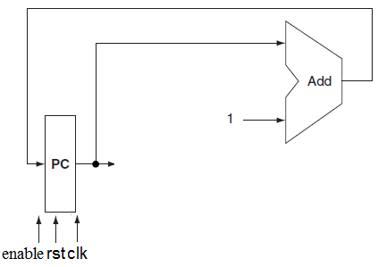

- Write Verilog module for instruction memory which is an array of registers (15 locations) (reference Figure 7.2)

module Instruction_Memory(input[3:0] address,
input read_en,
output [31:0] instruction);
Initialize memory with following hex values
8c0c0000 ; lw $12, 0($0)
8c0d0001 ; lw $13, 1($0)
8c0e0002 ; lw $14, 2($0)
8c0f0003 ; lw $15, 3($0)
018d4820 ; add $9, $12, $13
01cf5020 ; add $10, $14, $15
01494022 ; sub $8, $10, $9
ac080004 ; sw $8, 4($0)

- Combine the two units and name it

module Get_Instruction(input clock,
input reset,
input enable,
input read_en;
output [31:0]instruction);


- Simulate and verify the results

Post Lab
- Your Lab report should contain screenshots of waveforms
- Send separate .v files for each task as well.
Submission details
- Your lab report must comprise of two things; a .doc file and separate .v files for each code
- The .doc file must have a title page having your name, reg number and submission date written on it.
- The .doc file should have code and screen shots of waveforms and schematic.
  - Note: Screen shots of waveforms(cropped)
- Place your ‘RegNo_Name_LabNo.doc’ file and .v files in a folder named ‘RegNo_Name’.
- Now Zip it and give it Name ‘RegNo_Name_labno’. Send it as an attachment in an email with subject ‘LabNo’ to dilshad.sabir@comsats.edu.pk.
- Obviously replace ‘Reg’, ‘No’ and ‘Name’ in all these names with their values.
- The deadline is always the date of next lab. No lab report acceptable after that.

Critical Analysis / Conclusion
(By Student about Learning from the Lab)

Lab Assessment
Pre Lab | /5 | /25
Performance | /5
Results | /5
Viva | /5
Critical Analysis | /5
Instructor Signature and Comments

Lab # 08 Single Cycle MIPS Datapath (R-type and Load/Store)

Objective
- Fetch Instruction part of the Single Cycle MIPS Processor

Pre-Lab

Introduction: Our next task is implementing MIPS single cycle datapath shown in figure below. It will take more than one labs. MIPS has 32 registers each 32-bit wide. The instruction size is 32-bit too.

Figure 8.1
Common steps in instruction execution areƒ
- Fetching the instruction word from the instruction memoryƒ
- Decoding the instruction and reading from the register file or prepare a value from the immediate value (and PC)
- Performing an ALU operation ƒ
- Accessing the data memory (if needed)
- Making a jump (assigning a computed value to PC) (if needed)
- Writing to the register file

Implementation.

Supported Instruction set
We will implement only four instruction types, R-type, load and store, branch and jump. The R-type instructions which we will implement are add, sub, and, or and slt. Diagram below explains how each format divides the 32-bit instruction in to fields. 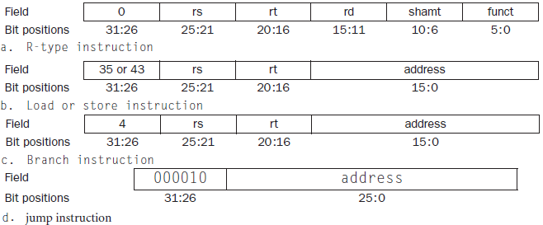
Figure 8.2

Building Datapath
The first thing that we need to build the datapath is an instruction memory and a mechanism to get new instruction on each clock cycle. The mechanism can be constructed using PC (Program Counter) and an adder. PC is a 32-bit register which holds the address of the next instruction and the adder increments PC on each clock cycle so that it points to the next instruction. Write (three) separate modules for each of these.

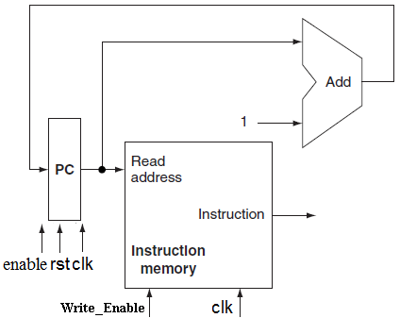
Figure 8.3. Instruction memory and the mechanism to get next instruction on every clock cycle

R-type

Today we will implement the R-type and load/store instructions only. R-type instructions for example add $rd,$rs,$rt reads two registers from register file ($rs and $rt), forwards them to ALU and writes the result back to the destination register ( $rd). So the components required are a register file and an ALU.
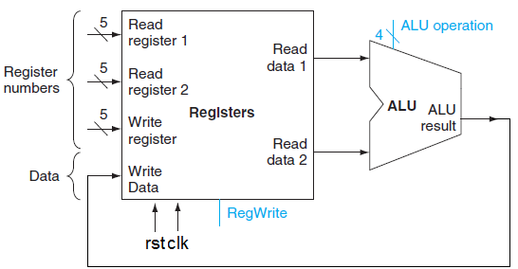
Figure 8.4
Control signals are shown in blue. Data is written only when ‘RegWrite’ is asserted. ‘ALU operation’ control signals are used in deciding the operations performed on operands(values read from registers).

Memory Unit(for Register file, Instruction and data memory)

Declaring Memory
In order to implement a Memory unit you will have to use an array of vectors.
reg [n-1:0] anyname [m-1:0];//Declaring m registers, each n-bit //wide.
For example in order to declare 8 registers each 32-bit wide, the statements used should be,
reg [31:0] reg_array [7:0];
In order to move the 6th word (1 word=32bits) of reg_file in another 32-bit vector ‘b’, the statement used should be
b= reg_file[5]

Output Mechanism
Data is read from memory asynchronously (independent of clock). It can be accomplished using an assign statement or an always behavior.
assign dataout=reg _array[address]

or

always @ (address)
dataout= reg _array[address];

Input Mechanism

Data is written to memory synchronously (with clock) when write enable signal is 1. It can be accomplished using an always behavior sensitive to positive or negative edge of clock

.
always @ (posedge clock)
if(write_enable)
reg _array[address]<=datain;

Test code with hexadecimal code
8c0c0000 ; lw $12, 0($0)
8c0d0001 ; lw $13, 1($0)
8c0e0002 ; lw $14, 2($0)
8c0f0003 ; lw $15, 3($0)
018d4820 ; add $9, $12, $13 # $3 = -1
01cf5020 ; add $10, $14, $15 # $5 = 1
01494022 ; sub $8, $10, $9 # $8 = -2
ac080004 ; sw $8, 4($0) # Store $9 in DMem[8]

In-Lab

Tasks

- Write a Verilog HDL module PC Plus adder

module pcplusadder(input clk,rst,enable, output[31:0] pc);

At reset pc=0, otherwise if enable=1 it keeps incrementing pc at each clock cycle. If enable=0 pc remains unchanged



- Write Verilog module for instruction memory which is an array of registers(15 locations)

module Instruction_Memory(input[31:0] address,
input clock,
input enable,
output [31:0]instruction);
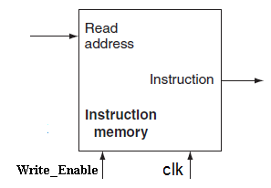
Initialize memory with following hex values

8c0c0000 ; lw $12, 0($0)
8c0d0001 ; lw $13, 1($0)
8c0e0002 ; lw $14, 2($0)
8c0f0003 ; lw $15, 3($0)
018d4820 ; add $9, $12, $13 # $3 = -1
01cf5020 ; add $10, $14, $15 # $5 = 1
01494022 ; sub $8, $10, $9 # $8 = -2
ac080004 ; sw $8, 4($0) # Store $9 in DMem[8]

- Combine the two units and name it

module Get_Instruction( input clock,
input reset,
input enable,
output [31:0]instruction);



Post Lab

- Your Lab report should contain screenshots of waveforms
- Send separate .v files for each task as well.
- Place your RegNo_Name_LabNo.doc file and .v files in a folder named RegNo_Name. Now Zip it and give it Name RegNo_Name_labno. Send it as an attachment in an email with subject LabNo to dilshadsabir@gmail.com. Obviously replace ‘Reg’, ‘No’ and ‘Name’ in all these names with their values.

Critical Analysis / Conclusion
(By Student about Learning from the Lab)

Lab Assessment
Pre Lab | /5 | /25
Performance | /5
Results | /5
Viva | /5
Critical Analysis | /5
Instructor Signature and Comments

Lab # 09 Single Cycle MIPS Datapath (R-type and Load/Store)

Objective
- RTL Modeling of single cycle datapath, R-type and Load/Store

Pre-Lab
The code that should be in the instruction memory was given in the last lab which is as follows.
Address in memory | Instruction | Corresponding  Hexadecimal Code
0 | add $9, $12, $13 | 018d4820
1 | add $10, $14, $15 | 01cf5020
3 | sub $8, $10, $9 | 1494022
Table 9.1

In-Lab
Tasks
In this lab you will create a module getoperand enclosed by green box in Figure 11.2, and then connect it to getinstruction. It reads operands specified in the instruction from register file. Register File contains all registers ($t, $s, $a, $v; total 32) of mips processors. These register contain operands. The output of the register file will be connected to ALU, which will perform the required task on operands. Read the Appendix as a reference of Verilog implementation of register file.
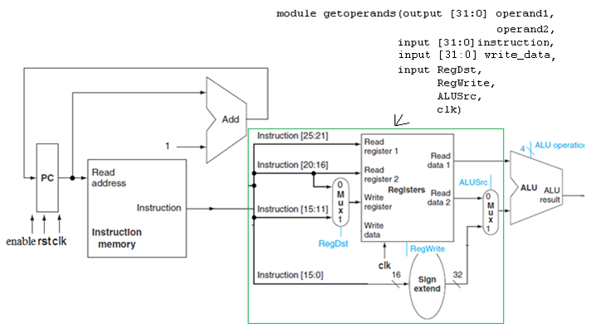
Figure 9.2
Program Counter | Data Read from Instruction Memory |  | Output of Complete Block  ‘Read data 1’ & ‘Read data 2’
 | Actual Instruction | Data Read
0 | add $9, $12, $13 | 018d4820 | Value of $12 and $13
1 | add $10, $14, $15 | 01cf5020 | Value of $14 and $15
2 | sub $8, $10, $9 | 1494022 | Value of $10 and $9

Table 9.2
Write module getoperands and combine it with module getinstruction (of Lab08). Test the combined
Submission details
- Your lab report, a .doc file, should contain properly commented Post-Lab task code, with Screenshots (of print preview) of Schematic and waveforms, and Critical Analysis.
- The report must have a title page in the prescribed format.
- Name the .doc file RegNo.docx; eg SP14-BCE-99.docx
- Email the report on dilshadsabir@gmail.com.

Critical Analysis / Conclusion
(By Student about Learning from the Lab)

Lab Assessment
Pre Lab | /5 | /25
Performance | /5
Results | /5
Viva | /5
Critical Analysis | /5
Instructor Signature and Comments

Lab # 10 Single Cycle MIPS Datapath (R-type and Load/Store)

Objective
- Adding ALU and Control Unit to the previous module

Pre-Lab
The following two modules are already connected in the previous Labs

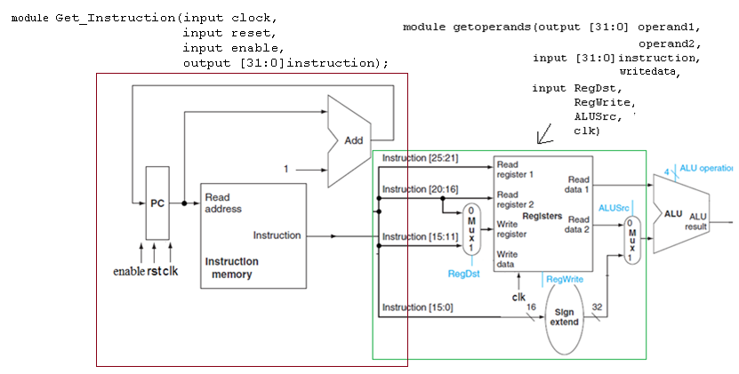
Figure 10.1

Today’s Tasks

ALU
Now connect the previous block to ALU.. The ALU is shown by diagram below
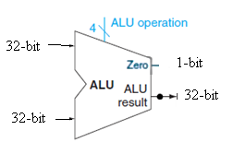
Figure 10.2
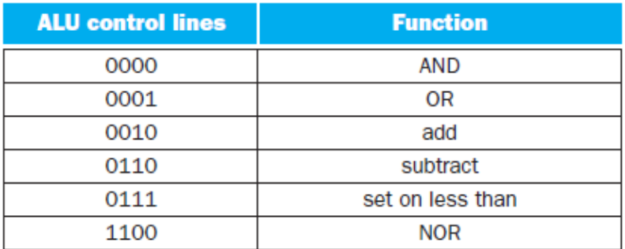
Table 10.1
It has two 32-bit data inputs, a 4-bit Control input ‘ALU operation’, one 32-bit output and one 1-bit output (Zero). The 1-bit output is useful for jump instruction such as SLT. It is used in the subtract instruction. If the result of subtraction is zero it is 1,otherwise it is zero.

TestBench
The final output of the complete circuit is given in the following table.
Program Counter | Data Read from Instruction Memory |  | Output of Complete Block  ‘Read data 1’ & ‘Read data 2’ | If ALU control lines =0010
 | Actual Instruction | Data Read
0 | add $9, $12, $13 | 018d4820 | Value of $12 and $13 | $12+$13
1 | add $10, $14, $15 | 01cf5020 | Value of $14 and $15 | $14+$15
2 | sub $8, $10, $9 | 1494022 | Value of $10 and $9 | $10+$9
Table 10.2

Control
Write module for Control Unit and ALU Control, and name it Control. Connect it with the previous blocks.

Control Unit
Note that for each instruction type, bits 26-31 are allocated for opcode which is used by the Control Unit to generate the relevant control signals for the instructions. Table given below explains the input to output relationship of control unit. Table for our complete implementation including branch and jump instructions is given here, so the control signals ‘Branch’ and ‘Jump’ will not be used today
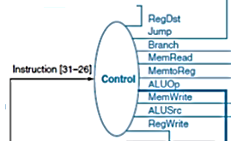

Figure 10.3

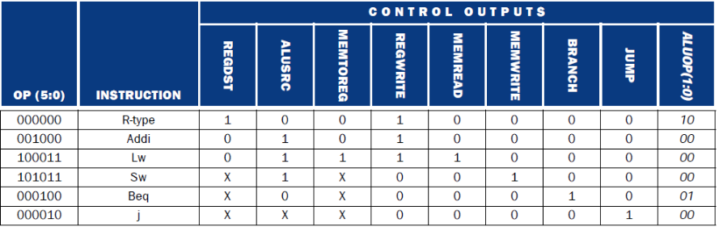
Table 10.3

ALU Control
It uses 2-bit ALUOP and 4-bits of ‘funct’ in R-type instructions to generate 4-bit output.(Use casex)
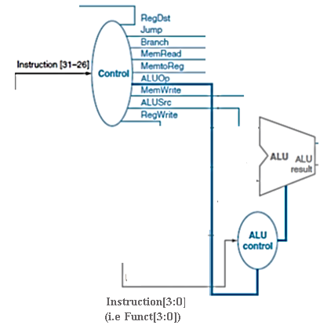

Figure 10.4

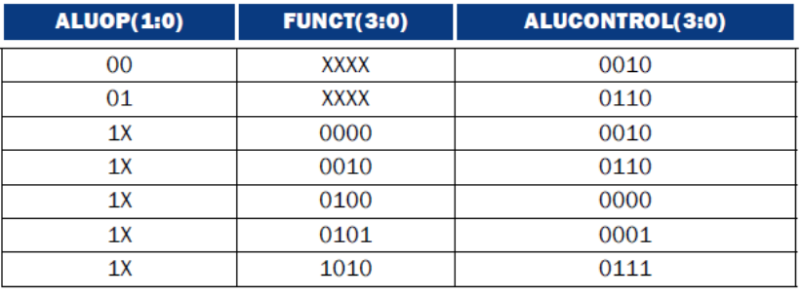
Table 10.4

Its output is input to ALU. Based on its output ALU decides the operation to be performed (add, sub, etc)

Test Bench

Figure 10.5 shows all the connected blocks. Write it’s testbench. ALU is it’s output.

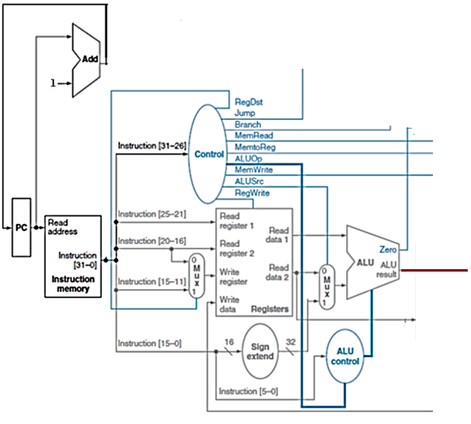
Figure 10.5

In-Lab

Tasks
- Add ALU to previous Blocks and write Testbench
- Add Control Unit to the previous blocks and write Testbench

- Your lab report must comprise of two things; a .doc file and separate .v files for each code
- The .doc file must have a title page having your name, reg number and submission date written on it. The doc file must have screenshots of waveforms and schematic.
  - Note: Screen shots of waveforms(cropped).
- Place your ‘RegNo_Name_LabNo.doc’ file and .asm files in a folder named ‘RegNo_Name’.
- Now Zip it and give it Name ‘RegNo_Name_labno’. Send it as an attachment in an email with subject ‘LabNo’ to dilshadsabir@gmail.com.
- Obviously replace ‘Reg’, ‘No’ and ‘Name’ in all these names with their values.

Critical Analysis / Conclusion
(By Student about Learning from the Lab)

Lab Assessment
Pre Lab | /5 | /25
Performance | /5
Results | /5
Viva | /5
Critical Analysis | /5
Instructor Signature and Comments

Lab # 11 Single Cycle MIPS Datapath (Data Memory and Branch)

Objective
- To add data memory and circuitry for branch instruction part of the Single Cycle MIPS Processor.

Pre-Lab
In this Lab you will add data memory and circuitry for branch instruction. The output for this block is the output of third mux which could be; either data read from data memory (lw), or, the output of ALU (R-type result or sw address).

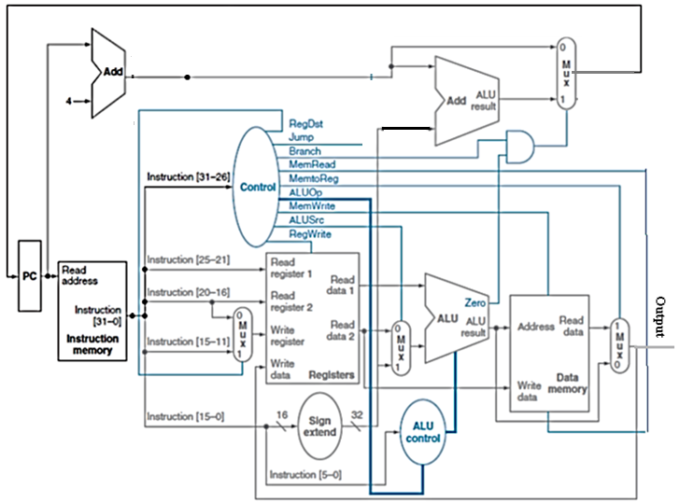
Figure 11.1

  - Part-1
In Part1 add data memory (20 locations, 32-bit wide) to previous block (up to ALU). Connect the output of data memory through mux to regfile. Data memory is similar to instruction memory except Data is only read when MemRead signal is asserted (value1). Data is written only at positive edge of clock when MemWrite is asserted.
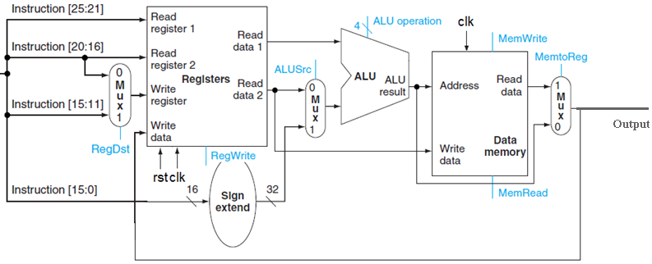Figure 11.2

    - Test Bench for Part 1

Write the following instruction in the instruction memory.

Address in memory | Instruction | With register Numbers | Corresponding  Hexadecimal Code
0 | lw $t1,4($t2) | lw $9,4($10) | 0x8d490004
1 | add $t3,$t2,$t1 | add $11,$10,$9 | 0x01495820
3 | sw $t3,5($t2) | sw $11,5($10) | 0xad4b0005
Table 11.1

- lw $t1,4($t2)(lw $9,4($10))
This instruction will read data from memory location “4 + value in $10”.
$9=DataMemory[4+$10]
For example if $t2($10)=8, this instruction will read data from memory location 4+8=12, and write the result in register $t1($9). Assign values of your choice to $t2, and memory location ‘4+$t2’.

Output= DataMemory[4+$10]

- add $t3,$t2,$t1(add $11,$10,$9)
It will add register $9 and $10 and write result in $12.

Output= $10+$9

- sw $t3,5($t2)(sw $11,5($10))

It will write the value of $11 to memory location “5 + value of $t2”. Assign value of your choice to $12.

Output= 5+$10
  - Part-2 (Branch)

Mips beq $rs,$rt,offset effects PC(program counter). On the basis of the comparison result of rs and rt it is decided whether to normally increment the PC, or, add the offset to it. If rs≠rt, PC=PC+1 (normal operation), otherwise PC=(PC+1)+offset.
If you will look the tables regarding Control Unit and ALU, you will see that beq instruction uses ‘Subtraction’ operation.
The circuit given below adds offset(instruction[15:0]) to PC+1. The mux selects between PC+1 and PC+1+offset, if Branch=1 and Zero=1(which means both operands are equal)
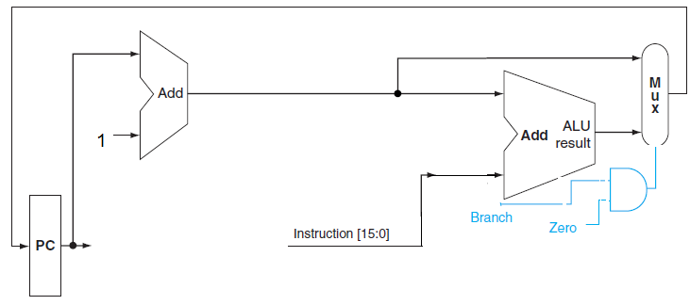
Figure 11.3

Offset is Instruction[15:0], and it is the relative address of instruction with the label from the beq instruction. For example for the following code
Label1: add $t1,$t1,$t0 #$t1=$t1+1
beq $t1,$t2,Label2
j Label1
Label2: add $t1,$t1,$t2
Code1
The value offset(distance between beq and Label2) is 1. It isn’t ‘2’ because PC=(PC+1)+offset will make the final change of +2
For the following code
Label: add $t1,$t1,$t0 #$t1=$t1+1
bne $t1,$t2,Label
Code2
The value of offset is -2, because PC=(PC+1)+offset will make the final change of -1

    - Test Bench for Part 2

Similar to part1 but this time you do not need to give the control signals since appropriate control signals will be given by Control Unit.

#Initializing Register File
#Move Value 0 in RegFile[2] (initializing)
#Move Value 1 in RegFile[3] (used for incrementing $2)
#Initialize RegFile[4] with any value of your choice, let’s say 456
#Initializing Data Memory
#Initialize DataMem[0] ----DataMem[10] with value stored in RegFile[4] which in this case is 456

The Following code has a loop that will run 10 times

loop:
lw $1,0($2) #$1=DataMem[$2]
add $2,$2,$3 #$2=$2+1
beq $1,$4,loop #Compare $1 with RegFile[4]

The Hex Code for instruction memory is
32’h8c410000
32’h00431020
32’h1024fffd

In-Lab

Today’s Task
Write Verilog HDL description of Data memory, Branch Datapath. Add to previous blocks for completion of the single cycle datapath.

- Your lab report must comprise of two things; a .doc file and separate .v files for each code
- The .doc file must have a title page having your name, reg number and submission date written on it. The doc file must have screenshots of waveforms and schematic.
  - Note: Screen shots of waveforms(cropped).
- Place your ‘RegNo_Name_LabNo.doc’ file and .v files in a folder named ‘RegNo_Name’.
- Now Zip it and give it Name ‘RegNo_Name_labno’. Send it as an attachment in an email with subject ‘LabNo’ to dilshadsabir@gmail.com.
- Obviously replace ‘Reg’, ‘No’ and ‘Name’ in all these names with their values.
The deadline is always the date of next lab. No lab report acceptable after that.

Critical Analysis / Conclusion
(By Student about Learning from the Lab)

Lab Assessment
Pre Lab | /5 | /25
Performance | /5
Results | /5
Viva | /5
Critical Analysis | /5
Instructor Signature and Comments

